PRN: 2421100256
Name:Ghadge Dhanshri Prakash
Class:MCA-I
Roll No:12

ASSIGNMENT NO :1
Q. Write HTML Program to create Class TimeTable.
<!DOCTYPE html>
<html>
<head>
<title>Time Table</title>
<style>
body {
background-color: lightgrey;
}
h2 {
text-align: center;
color: red;
}
h3 {
text-align: center;
color: green;
}
table {
text-align: center;
border-collapse: collapse;
}
th {
background-color: lightSalmon;
}
td {
background-color: lightPink;
}
</style>
</head>
<body>
<h2>BHARATI VIDYAPEETH TO BE UNIVERSITY, PUNE<br>
YASHWANTRAO MOHITE INSTITUTE OF MANAGEMENT KARAD
</h2>
<h3>ACADEMIC YEAR 2024-25<br> MCA-I SEM-II (2024-25)</h3>
<hr>
<h3 style="color:red">Time Table</h3>
<center>
<table border="1">
<tr>
<th></th>
<th>MON</th>
<th>TUE</th>
<th>WED</th>
<th>THU</th>
<th>FRI</th>
<th>SAT</th>
<th>Lecture hall/Lab</th>
</tr>
<tr>
<td>10:30-11:30PM</td>
<td>CC<br>[ppp]</td>
<td>CC<br>[ppp]</td>
<td>CC<br>[ppp]</td>
<td>PYTHON<br>[AS]</td>
<td>PYTHON<br>[AS]</td>
<td>PYTHON<br>[AS]</td>
<td>Multi</td></tr>
<tr>
<td>11:30-12:30PM</td>
<td>PYTHON-Lab<br>[AS]</td>
<td>PYTHON-Lab<br>[AS]</td>
<td>PYTHON-Lab<br>[AS]</td>
<td>WST Lab<br>[AAP]</td>
<td>WST Lab<br>[AAP]</td>
<td>WST Lab<br>[AAP]</td>
<td>Lab-3</td>
</tr>
<tr>
<td>12:30-1:30PM</td>
<td>WST<br>[AJ]</td>
<td>WST<br>[AJ]</td>
<td>WST<br>[AJ]</td>
<td>OOSE<br>[PRR]</td>
<td>OOSE<br>[PRR]</td>
<td>OOSE<br>[PRR]</td>
<td>Lab-3</td>
</tr>
<tr>
<td>1:30-2:00PM</td>
<th colspan="7">BREAK</th>
</tr>
<tr>
<td>2:00-3:00</td>
<td>DWDM<br>[SVD]</td>
<td>DWDM<br>[SVD]</td>
<td>DWDM<br>[SVD]</td>
<td>DT<br>[PRR]</td>
<td>DT<br>[PRR]</td>
<td>DWDM<br>[SVD]</td>
<td>Lab-3</td>
</tr> </table>
<br>
<table border="1">
<tr>
<th>SR.NO</th>
<th></th>
<th>Subject Name</th>
<th>Faculty Name</th>
</tr>
<tr>
<td>201</td>
<td><a href="C:\Users\Admin\Desktop\Notes\OOSE.pdf">OOSE</a></td>
<td>Object Oriented Software Engineering</td>
<td>Prof. P.R. Rasal</td>
</tr>
<tr>
<td>202</td>
<td><a href="C:\Users\Admin\Desktop\Notes\CC.pdf">CC</a></td>
<td>Cloud Computing Concepts</td>
<td>Dr. P.P. Patil<br><b>Class Coordinator</b></td>
</tr>
<tr>
<td>203</td>
<td><a href="C:\Users\Admin\Desktop\Notes\PYTHON.pdf">DS</a></td>
<td>Data Structure using Python</td>
<td>Mrs. Ashwini Sarate</td>
</tr>
<tr>
<td>204</td>
<td><a href="C:\Users\Admin\Desktop\Notes\DWDM.pdf">DWDM</a></td>
<td>Data Warehouse and Data Mining</td>
<td>Dr. Mrs. Sheetal Deshmukh</td>
</tr>
<tr>
<td>205</td>
<td><a href="C:\Users\Admin\Desktop\Notes\WST.pdf">WST</a></td>
<td>Web Supporting Technologies</td>
<td>Mrs. Archana Jadhav</td>
</tr>
<tr>
<td>206</td>
<td><a href="C:\Users\Admin\Desktop\Notes\python lab.pdf">Lab on DS</a></td>
<td>Lab on Data Structure using Python</td>
<td>Mrs. Ashwini Sarate</td>
</tr>
<tr>
<td>207</td>
<td></td>
<td>Minor Project-I</td>
<td>Dr. P.P. Patil</td>
</tr>
<tr>
<td>208<br><hr>209</td>
<td></td>
<td>
MOOCS-II*<br><br>
<a href="C:\Users\Admin\Desktop\Notes\Digiital Technology.pdf">Open Course-II** - Digital Technology</a>
</td>
<td>
Dr. P.P. Patil
<hr>
Prof. P.R. Rasal
</td>
</tr>
</table>
</center>
</body>
</html>
OUTPUT
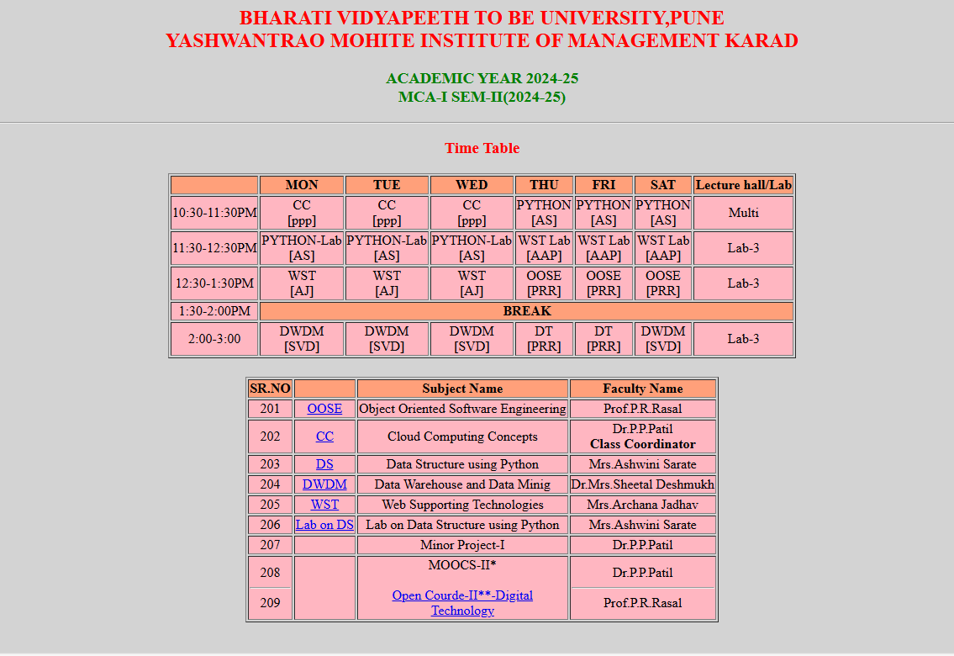

PRN: 2421100256
Name:Ghadge Dhanshri Prakash
Class:MCA-I
Roll No:12

ASSIGNMENT NO :2
Q. Write HTML Program to Design Admmision Portal.
<!DOCTYPE html>
<html>
<head>
<title>BVDU</title>
<style>
.BVDU {
display: flex;
align-items: left;}
.ymim {
display: flex;
align-items: right;}
h1 {
text-align: center;
font-size: 38px;}
.mainBVDU img {
height: 78vh;
width: 55rem;
}
marquee {
background-color: green;
color: white;
font-weight: bold;
font-size: 38px;
}
.mainBVDU {
/* Empty class, add styles if needed */
}
</style>
</head>
<body>
<div class="BVDU">
<img src="C:\Users\Admin\Desktop\BVDU-logo.jpg" alt="BVDU Logo">
<span>
<h1>BHARATI VIDYAPEETH<br>YASHWANTRAO MOHITE INSTITUTE OF MANAGEMENT KARAD</h1>
<hr></span>
<div class="ymim">
<img src="C:\Users\Admin\Desktop\ymim-logo.webp" alt="YMIM Logo">
</div>
</div>
<center>
<div class="mainBVDU">
<a href="C:\Users\Admin\Desktop\tableBVDU.html">
<img src="C:\Users\Admin\Desktop\addmission.webp" alt="Admission Image">
<marquee direction="right" scrollamount="20">
Admission Open 2025 Click here.....
</marquee></a></div></center>
</body>
</html>
OUTPUT:


PRN: 2421100256
Name:Ghadge Dhanshri Prakash
Class:MCA-I
Roll No:12
ASSIGNMENT NO :3
Q. Demonstrate Frames Using HTML.
<!DOCTYPE html>
<html>
<head>
<title>Frame tag</title>
</head>

<frameset cols="25%, 50%, 25%">
<frame src="https://www.javatpoint.com/html-table">
<frame src="https://www.javatpoint.com/css-table">
<frame src="https://www.javatpoint.com/html-table">
</frameset>
<body>
</body>
</html>
OUTPUT
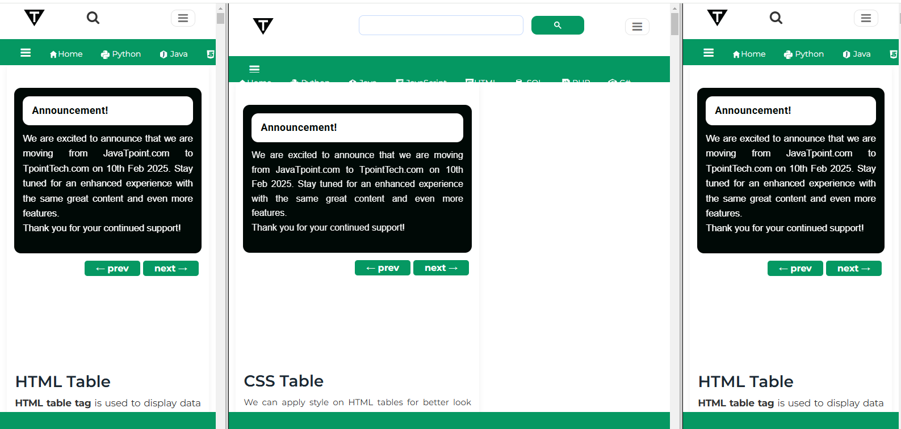

PRN: 2421100256
Name:Ghadge Dhanshri Prakash
Class:MCA-I
Roll No:12
ASSIGNMENT NO :4
Q. Write HTML Program that embeds and Plays Both Audio & Video Files.
<!DOCTYPE html>
<html>
<head>
<title>Page Title</title>
<style>
h1 {
text-align: center;
}
</style></head>
<body>
<h1>AUDIO AND VIDEO</h1>
<h2>Click play button to play audio</h2>
<audio src="./test.mp3" controls></audio>
<h2>Click play button to play video</h2>
<video src="./test.mp4" controls></video>
</body>
</html>
OUTPUT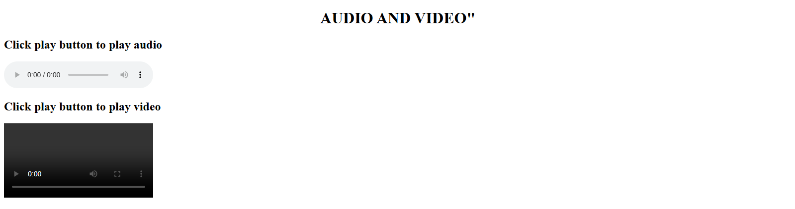

PRN: 2421100256
Name:Ghadge Dhanshri Prakash
Class:MCA-I
Roll No:12
ASSIGNMENT NO :5
Q. Write HTML Program to demonstrate List tag.
<!DOCTYPE html>
<html lang="en">
<head>
<meta charset="UTF-8">
<meta name="viewport" content="width=device-width, initial-scale=1.0">
<title>MCA - i</title>
<style>
body{
background-color: rgba(255, 145, 0, 0.842);
}
h1{
color: red;
font-family: 'Franklin Gothic Medium', 'Arial Narrow', Arial, sans-serif;
margin-left: 30% ;
}
h2{
color: green;
font-family: 'Gill Sans', 'Gill Sans MT', Calibri, 'Trebuchet MS', sans-serif;
}
div {
background-color: lightblue;
margin-left: 15%;
padding: 20px;
width: 70%;
margin-top: 5%;
}
div h2{
margin-left: 32%;
}
ul{
margin-left: 30%;
}

</style>
</head>
<body>
<h1>Subject : WEB SUPPORTING TECHNOLOGIES</h1>
<hr>
<div>
<h2>Syllabus</h2>
<ul type="square">
<li>Unit 1: Introduction to Web Technologies
<ul>
<li>HTML Basics</li>
<li>CSS Basics</li>
<li>JavaScript Basics</li>
</ul>
</li>
<li>Unit 2: Advanced HTML and CSS
<ul>
<li>HTML5 Features</li>
<li>CSS3 Features</li>
<li>Responsive Design</li>
</ul>
</li>
<li>Unit 3: JavaScript and DOM Manipulation
<ul>
<li>JavaScript Functions</li>
<li>Event Handling</li>
<li>DOM Manipulation</li>
</ul>
</li>
<li>Unit 4: Web Hosting and Deployment
<ul>
<li>Web Hosting Basics</li>
<li>FTP and File Management</li>
<li>Deploying a Website</li>
</ul>
</li>
</ul>
</div>
</body>
</html>
OUTPUT
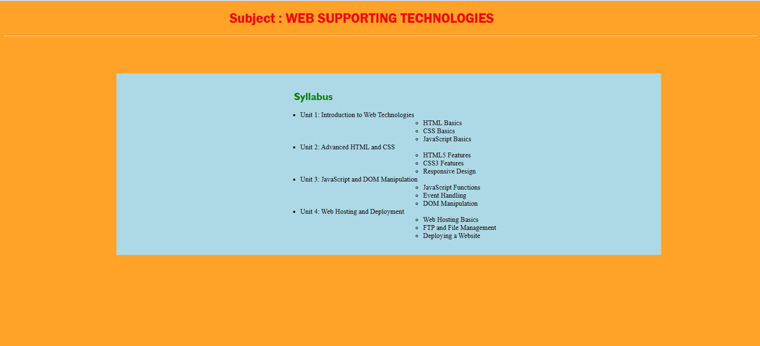

PRN: 2421100256
Name:Ghadge Dhanshri Prakash
Class:MCA-I
Roll No:12
ASSIGNMENT NO :6
Q. Design Student Registration Form using HTML.
<!DOCTYPE html>
<html lang="en">
<head>
<meta charset="UTF-8">
<meta name="viewport" content="width=device-width, initial-scale=1.0">
<title>Login and Registration Form</title>
<style>
* {
margin: 0;
padding: 0;
box-sizing: border-box;
font-family: Arial, Helvetica, sans-serif; }
body {
font-family: Arial, sans-serif;
background-color: #f4f4f4;
margin: 0;
padding: 0; }
.clg-name {
text-align: center;
margin: 20px 0; }
.container {
display: flex;
justify-content: center;
gap: 120px;
width: 1300px;
margin: 0 auto;
padding: 20px; }
.main-div {
background-color: #fff;
width: 1300px;
height: 700px;
box-shadow: 0 0 10px rgba(0, 0, 0, 0.1);
padding: 20px;
margin: 0 auto;
margin-bottom: 80px; }
form {
display: flex;
flex-direction: column; }
label {
margin-top: 10px;
font-weight: bold; }
input[type="text"],
input[type="date"],
input[type="tel"],
input[type="email"],
textarea {
padding: 10px;
margin-top: 5px;
border: 1px solid #ccc;
border-radius: 5px; }
textarea {
resize: vertical; }
input[type="radio"] {
margin-right: 50px;
}
select {
width: 364px;
padding: 10px;
margin-top: 5px;
border: 1px solid #ccc;
border-radius: 5px;
background-color: #fff;
}
button {
margin-top: 20px;
padding: 10px;
border: none;
border-radius: 5px;
cursor: pointer;
}
button[type="submit"] {
background-color: #4CAF50; }
button[type="reset"] {
background-color: #f44336; }
button[type="Exit"] {
background-color: #0d24a3;}
button[type="button"] {
background-color: #555; }
button:hover {
background-color: #bea61b; }
h2 {
padding: 10px; }
h1{
margin-top: 20px;
}
.subjects {
display: flex;
}
.form-1 , .form-2{
margin-top: 10px;
}
input {
width: 364px;
}
.buttons{
margin-left: 50%;
}
</style></head>
<body>
<div class="clg-name">
<h2>BHARATI VIDYAPEETH DEEMED TO BE UNIVERSITY, PUNE</h2>
<h3>YASHWANTRAO MOHITE INSTITUTE OF MANAGEMENT KARAD</h3>
<h1>Student Registration Form</h1>
</div>
<div class="main-div">
<div class="container">
<form action="" class="form-1">
<!-- Username -->
<label for="fname">FirstName : </label>
<input type="text" name="fname" id="fname" placeholder="Enter your first name">
<!-- Middle Name -->
<label for="mname">MiddleName : </label>
<input type="text" name="mname" id="mname" placeholder="Enter your middle name">
<!-- Last Name -->
<label for="lname">LastName : </label>
<input type="text" name="lname" id="lname" placeholder="Enter your last name">
<!-- Mother's Name -->
<label for="mname">Mother's Name : </label>
<input type="text" name="mname" id="mname" placeholder="Enter your mother's name">
<!-- Gender -->
<label for="Gender">Gender : </label>
<label for="male">Male</label>
<input type="radio" name="gender" value="male" id="male">
<label for="female">Female</label>
<input type="radio" name="gender" value="female" id="female">
<!-- Date of Birth -->
<label for="dob">Date of Birth : </label>
<input type="date" name="dob" id="dob">
<!-- Address -->
<label for="address">Address : </label>
<textarea name="address" id="address" placeholder="Enter your address"></textarea>
</form>
<form action="" class="form-2">
<!-- Mobile Number -->
<label for="mobile">Mobile No : </label>
<input type="tel" name="mobile" id="mobile" placeholder="Enter your mobile number">
<!-- Email -->
<label for="email">Email : </label>
<input type="email" name="email" id="email" placeholder="Enter your email">
<!-- Department -->
<label for="department">Department : </label>
<select name="department" id="department">
<option value="Management">Management</option>
<option value="Computer Application">Computer Applications</option>
</select>
<!-- Course -->
<label for="course">Course : </label>
<select name="course" id="course">
<option value="MBA">MBA</option>
<option value="MCA">MCA</option>
<option value="BCA">BCA</option>
<option value="BBA">BBA</option>
</select>
<!-- Subject -->
<label for="subject">Subjects : </label>
<div class="subjects">
<div id="subject-1">
<input type="checkbox" name="subject" value="Mathematics">Mathematics <br>
<input type="checkbox" name="subject" value="Physics"> Physics<br>
input type="checkbox" name="subject" value="Chemistry"> Chemistry<br>
<input type="checkbox" name="subject" value="Biology"> Biology<br>
<input type="checkbox" name="subject" value="Computer Science"> Computer Science<br>
</div>
<div id="subject-2">
<input type="checkbox" name="subject" value="Economics"> Economics<br>
<input type="checkbox" name="subject" value="History"> History<br>
<input type="checkbox" name="subject" value="Geography"> Geography<br>
<input type="checkbox" name="subject" value="English"> English<br>
<input type="checkbox" name="subject" value="Political Science"> Political Science<br>
</div></div>
</form></div>
<div class="buttons">
<button type="submit">Submit</button>
<button type="reset">Reset</button>
<button type="Exit">Exit</button>
</div>
</div>
</body>
</html>
OUTPUT
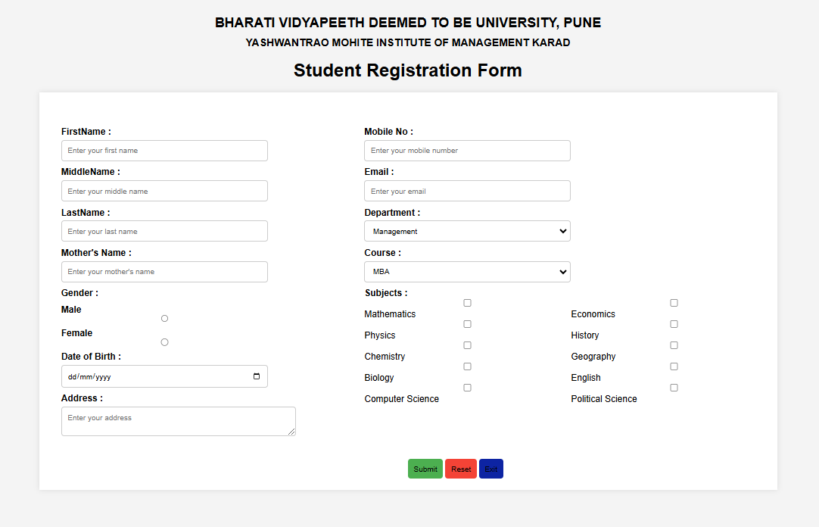
PRN: 2421100256
Name:Ghadge Dhanshri Prakash
Class:MCA-I
Roll No:12
ASSIGNMENT NO :7
Q. Demonstrate CSS using Inline, Internal & External CSS.
<!DOCTYPE html>
<html lang="en">
<head>
<meta charset="UTF-8">
<meta name="viewport" content="width=device-width, initial-scale=1.0">
<title>Internal & External CSS Demo</title>
<!-- Linking External CSS -->
<link rel="stylesheet" href="styles.css">
<!-- Internal CSS -->
<style>
h1 {
color: darkblue;
text-align: center;
}
.internal-style {
background-color: lightgray;
padding: 10px;
text-align: center;
font-size: 18px;
}
</style>
</head>
<body>
<h1>Internal & External CSS Example</h1>
<div class="internal-style">
This is styled using **Internal CSS**.
</div>
<p class="external-style">
This paragraph is styled using **External CSS**.
</p>
</body>
</html>
Styles.css:
.external-style {
background-color: lightblue;
color: darkred;
padding: 15px;
text-align: center;
font-size: 18px;
}
OUTPUT


PRN: 2421100256
Name:Ghadge Dhanshri Prakash
Class:MCA-I
Roll No:12

ASSIGNMENT NO :8
Q. Develop Basic Calculator Using HTML, CSS, JavaScript that Performs Arithmetic Operations.
<!DOCTYPE html>
<html lang="en">
<head>
<meta charset="UTF-8">
<meta name="viewport" content="width=device-width, initial-scale=1.0">
<title>Simple Calculator</title>
<style>
body {
font-family: Arial, sans-serif;
text-align: center;
margin: 20px;
}
input {
margin: 10px;
padding: 5px;
width: 150px;
}
button {
margin: 5px;
padding: 10px 20px;
cursor: pointer;
}
#result {
margin-top: 20px;
font-size: 1.2em;
font-weight: bold;
}
input {
display: list-item;
border-radius: 10px;
width: 250px;
}
.main {
background-color: aqua;
padding: 20px;
border-radius: 10px;
height: 250px;
width: 300px;
margin-top: 10vh;
margin-left: 40vw;
}

#operation {
width: 265px;
padding: 5px;
border-radius: 10px;
margin-right: 20px;
}
button {
margin-top: 20px;
padding: 10px 20px;
border-radius: 10px;
background-color: blue;
color: white;
font-weight: bold;
}
</style>
</head>
<body>
<div class="main">
<h1>Calculator</h1>
<div class="input">
<input type="number" id="num1" placeholder="Enter first number">

</div>
<div class="input">
<input type="number" id="num2" placeholder="Enter second number">
</div>
<div class="operation">
<select id="operation">
<option value="+">Add</option>
<option value="-">Subtract</option>
<option value="*">Multiply</option>
<option value="/">Divide</option>
</select>

</div>
<div class="button">
<button onclick="performOperation()">Calculate</button>
</div>
<div id="result"></div>
</div>
<script>
function performOperation() {
const num1 = parseFloat(document.getElementById('num1').value);
const num2 = parseFloat(document.getElementById('num2').value);
const operator = document.getElementById('operation').value;
let result;

if (isNaN(num1) || isNaN(num2)) {
result = "Please enter valid numbers.";
} else {
switch (operator) {
case '+':
result = num1 + num2;
break;
case '-':
result = num1 - num2;
break;
case '*':
result = num1 * num2;
break;
case '/':
result = num2 !== 0 ? num1 / num2 : "Cannot divide by zero.";
break;
default:
result = "Invalid operation.";
}
}
document.getElementById('result').innerText = `Result: ${result}`;
}
</script>
</body>
</html>
OUTPUT
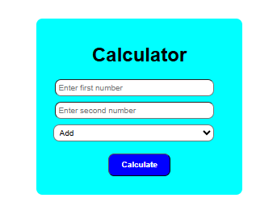
PRN: 2421100256
Name:Ghadge Dhanshri Prakash
Class:MCA-I
Roll No:12
ASSIGNMENT NO :9
Q. Create MarkList Application Using HTML,CSS, JavaScript.
<!DOCTYPE html>
<html lang="en">
<head>
<meta charset="UTF-8">
<meta name="viewport" content="width=device-width, initial-scale=1.0">
<title>Marks, Grade, and Result Calculation</title>
<style>
body {
font-family: Arial, sans-serif;
padding: 20px;
background-color: #f4f4f4;
}
.container {
max-width: 600px;
margin: 0 auto;
padding: 20px;
background-color: #fff;
border-radius: 8px;
box-shadow: 0 0 10px rgba(0, 0, 0, 0.1);
}
h2 {
text-align: center;
color: #333;
}
label {
margin: 10px 0;
font-weight: bold;
display: block;
}
input {
width: 100%;
padding: 10px;
margin: 8px 0;
border: 1px solid #ccc;
border-radius: 4px;
}
button {
width: 100%;
padding: 10px;
background-color: #4CAF50;
color: white;
border: none;
border-radius: 4px;
font-size: 16px;
}
button:hover {
background-color: #45a049;
}
.result {
margin-top: 20px;
font-size: 18px;
text-align: center;
}
.result input {
font-weight: bold;
text-align: center;
}
</style>
</head>
<body>
<div class="container">
<h2>Marks, Grade, and Result Calculation</h2>
<label for="marks1">Subject 1 Marks:</label>
<input type="number" id="marks1" placeholder="Enter marks for Subject 1" required>
<label for="marks2">Subject 2 Marks:</label>
<input type="number" id="marks2" placeholder="Enter marks for Subject 2" required>
<label for="marks3">Subject 3 Marks:</label>
<input type="number" id="marks3" placeholder="Enter marks for Subject 3" required>
<label for="marks4">Subject 4 Marks:</label>
<input type="number" id="marks4" placeholder="Enter marks for Subject 4" required>
<label for="marks5">Subject 5 Marks:</label>
<input type="number" id="marks5" placeholder="Enter marks for Subject 5" required>
<button onclick="calculateResult()">Calculate Result</button>
<div class="result">
<label for="totalMarks">Total Marks:</label>
<input type="text" id="totalMarks" readonly>
<label for="percentage">Percentage:</label>
<input type="text" id="percentage" readonly>
<label for="grade">Grade:</label>
<input type="text" id="grade" readonly>
<label for="result">Result:</label>
<input type="text" id="result" readonly>
</div>
</div>
<script>
function calculateResult() {
// Get the marks from the input fields
var marks1 = parseFloat(document.getElementById("marks1").value);
var marks2 = parseFloat(document.getElementById("marks2").value);
var marks3 = parseFloat(document.getElementById("marks3").value);
var marks4 = parseFloat(document.getElementById("marks4").value);
var marks5 = parseFloat(document.getElementById("marks5").value);
// Validate input to ensure marks are entered
if (isNaN(marks1) || isNaN(marks2) || isNaN(marks3) || isNaN(marks4) || isNaN(marks5)) {
alert("Please enter valid marks for all subjects.");
return;
}
// Calculate total marks and percentage
var totalMarks = marks1 + marks2 + marks3 + marks4 + marks5;
var percentage = (totalMarks / 500) * 100;
// Determine grade based on percentage
var grade = "";
if (percentage >= 90) {
grade = "A+";
} else if (percentage >= 80) {
grade = "A";
} else if (percentage >= 70) {
grade = "B+";
} else if (percentage >= 60) {
grade = "B";
} else if (percentage >= 50) {
grade = "C";
} else if (percentage >= 40) {
grade = "D";
} else {
grade = "F";
}
// Determine result (Passed or Failed)
var result = percentage >= 40 ? "Passed" : "Failed";
// Display the results in textboxes
document.getElementById("totalMarks").value = totalMarks;
document.getElementById("percentage").value = percentage.toFixed(2) + "%";
document.getElementById("grade").value = grade;
document.getElementById("result").value = result;
}
</script>
</body>
</html>
OUTPUT
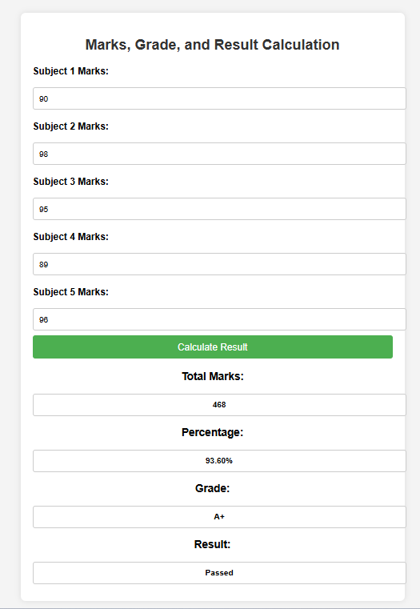

PRN: 2421100256
Name:Ghadge Dhanshri Prakash
Class:MCA-I
Roll No:12
ASSIGNMENT NO :10
Q. Demonstration of Mathematical functions using JavaSCript.
<!DOCTYPE html>
<html>
<head>
<title>JavaScript Math Functions</title>
<style>
body {
font-family: Arial, sans-serif;
padding: 20px;
background-color: #eef2f3;
}
h2 {
text-align: center;
}
.output {
background-color: #fff;
padding: 15px;
margin: 20px auto;
width: 80%;
border-radius: 8px;
box-shadow: 0 0 10px rgba(0,0,0,0.1);
}
button {
padding: 10px 15px;
font-size: 16px;
margin-top: 10px;
display: block;
margin-left: auto;
margin-right: auto;
}
pre {
background-color: #f4f4f4;
padding: 10px;
border-radius: 5px;
}
</style>
</head>
<body>
<h2>Demonstration of JavaScript Mathematical Functions</h2>
<button onclick="showMathFunctions()">Show Math Functions</button>
<div class="output" id="outputBox">
<pre id="result">Click the button to see the output...</pre>
</div>
<script>
function showMathFunctions() {
let x = 5.7;
let y = 4;
let output = `
Original Numbers:
x = ${x}
y = ${y}
Math.round(x): ${Math.round(x)}
Math.floor(x): ${Math.floor(x)}
Math.ceil(x): ${Math.ceil(x)}
Math.trunc(x): ${Math.trunc(x)}
Math.pow(x, y): ${Math.pow(x, y)}
Math.sqrt(25): ${Math.sqrt(25)}
Math.cbrt(27): ${Math.cbrt(27)}
Math.max(10, 20, 30): ${Math.max(10, 20, 30)}
Math.min(10, 20, 30): ${Math.min(10, 20, 30)}
Math.abs(-50): ${Math.abs(-50)}
Math.sign(-10): ${Math.sign(-10)}
Math.sign(0): ${Math.sign(0)}
Math.sign(10): ${Math.sign(10)}
Random Number (0-1): ${Math.random().toFixed(4)}
Random Integer (1-100): ${Math.floor(Math.random() * 100) + 1};
document.getElementById("result").innerText = output;
}
</script>
</body>
</html>

OUTPUT

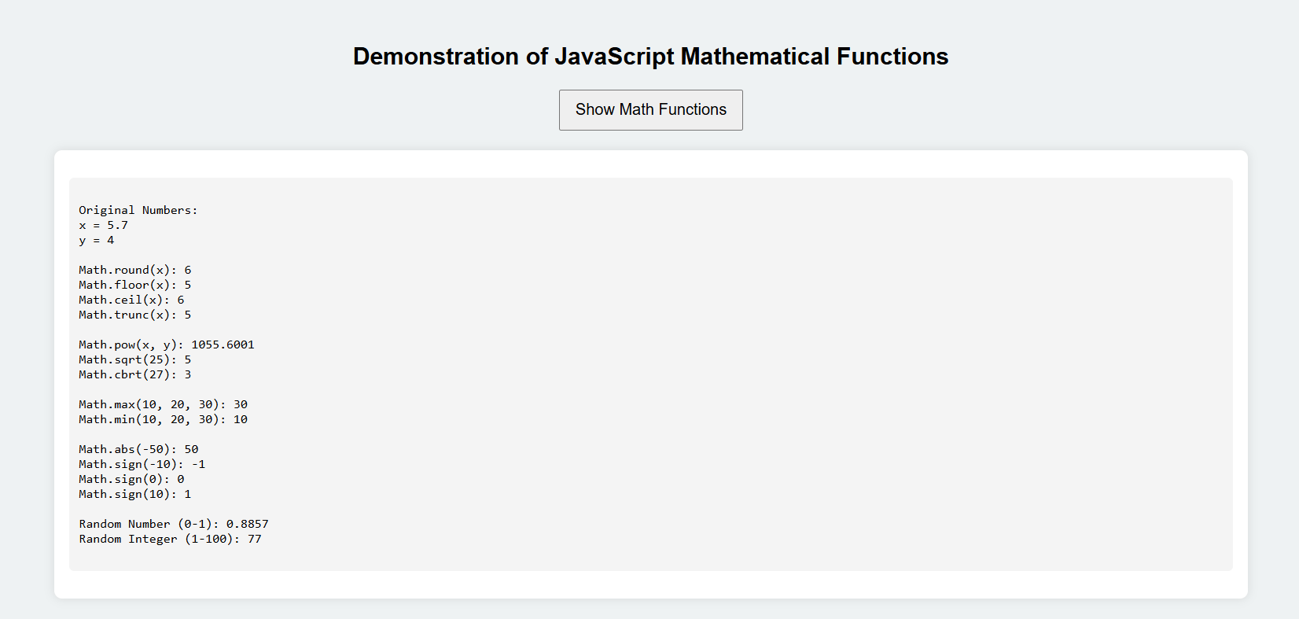

PRN: 2421100256
Name:Ghadge Dhanshri Prakash
Class:MCA-I
Roll No:12
ASSIGNMENT NO :11
Q. Demonstration of strings functions using Javascript.
<!DOCTYPE html>
<html lang="en">
<head>
<meta charset="UTF-8">
<title>String Functions Demo</title>
<style>
body {
font-family: Arial, sans-serif;
padding: 20px;
background: #f0f8ff;
}
.container {
max-width: 600px;
margin: auto;
background: white;
border-radius: 10px;
padding: 20px;
box-shadow: 0 0 10px rgba(0,0,0,0.1);
}
h2 {
text-align: center;
color: #333;
}
button {
padding: 10px 20px;
background-color: #4CAF50;
color: white;
font-size: 16px;
border: none;
border-radius: 5px;
cursor: pointer;
display: block;
margin: 20px auto;
}
button:hover {
background-color: #45a049;
}
.output {
margin-top: 20px;
background: #f9f9f9;
padding: 15px;
border-radius: 5px;
line-height: 1.6;
}
</style>
</head>
<body>
<div class="container">
<h2>Demonstration of String Functions using JavaScript</h2>
<button onclick="showStringFunctions()">Show String Functions</button>
<div class="output" id="result"></div>
</div>
<script>
function showStringFunctions() {
let str = " Hello JavaScript! ";
let output = "";
output += "Original String: '" + str + "'<br>";
output += "Length: " + str.length + "<br>";
output += "Uppercase: " + str.toUpperCase() + "<br>";
output += "Lowercase: " + str.toLowerCase() + "<br>";
output += "Trimmed: '" + str.trim() + "'<br>";
output += "Substring (0, 5): " + str.substring(0, 5) + "<br>";
output += "Char at 6: " + str.charAt(6) + "<br>";
output += "Index of 'Java': " + str.indexOf("Java") + "<br>";
output += "Replace 'JavaScript' with 'World': " + str.replace("JavaScript", "World") + "<br>";
output += "Split by space: " + str.trim().split(" ") + "<br>";
output += "Includes 'Script': " + str.includes("Script") + "<br>";
document.getElementById("result").innerHTML = output;
}
</script>
</body>
</html>

OUTPUT

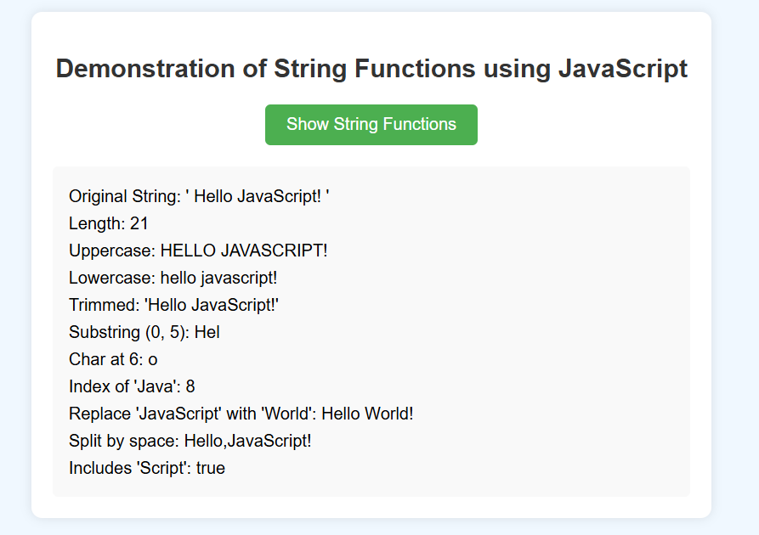

PRN: 2421100256
Name:Ghadge Dhanshri Prakash
Class:MCA-I
Roll No:12
ASSIGNMENT NO :12
Q. Demonstration JavaScript Events.
<!DOCTYPE html>
<html lang="en">
<head>
<meta charset="UTF-8">
<title>JavaScript Events Demo</title>
<style>
body {
font-family: Arial, sans-serif;
padding: 30px;
background-color: #f0f0f0;
}
.container {
max-width: 600px;
margin: auto;
background-color: white;
padding: 20px;
border-radius: 10px;
box-shadow: 0 0 10px rgba(0,0,0,0.2);
}
button, input {
padding: 10px;
margin: 10px 0;
font-size: 16px;
border-radius: 5px;
border: 1px solid #ccc;
}
#hoverBox {
width: 100%;
padding: 20px;
background-color: #d1ecf1;
text-align: center;
margin-top: 10px;
border-radius: 5px;
transition: background 0.3s;
}
.output {
margin-top: 15px;
font-weight: bold;
}
</style>
</head>
<body>
<div class="container">
<h2>JavaScript Events Demonstration</h2>
<button onclick="onClickEvent()">Click Me</button><br>
<input type="text" id="textInput" onkeyup="onKeyUpEvent()" placeholder="Type something..."><br>
<div id="hoverBox" onmouseover="onMouseOver()" onmouseout="onMouseOut()">
Hover over this box
</div>
<p class="output" id="outputText"></p>
</div>
<script>
function onClickEvent() {
document.getElementById("outputText").innerHTML = "Button was clicked!";
}
function onKeyUpEvent() {
let input = document.getElementById("textInput").value;
document.getElementById("outputText").innerHTML = "You typed: " + input;
}

function onMouseOver() {
document.getElementById("hoverBox").style.backgroundColor = "#c3e6cb";
document.getElementById("outputText").innerHTML = "Mouse is over the box!";
}
function onMouseOut() {
document.getElementById("hoverBox").style.backgroundColor = "#d1ecf1";
document.getElementById("outputText").innerHTML = "Mouse left the box.";
}
</script>
</body>
</html>

OUTPUT

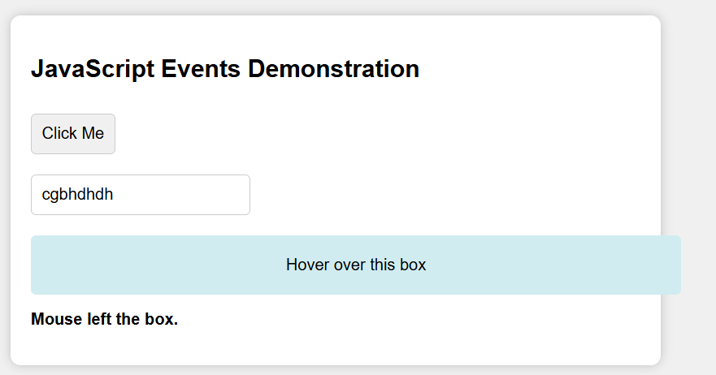

PRN: 2421100256
Name:Ghadge Dhanshri Prakash
Class:MCA-I
Roll No:12
ASSIGNMENT NO :13
Q. Write a javascript Code to display Pyramid
<!DOCTYPE html>
<html lang="en">
<head>
<meta charset="UTF-8">
<title>Star Pyramid</title>
<style>
body {
font-family: monospace;
background-color: #f4f4f4;
padding: 20px;
}
h2 {
text-align: center;
}
.pyramid {
white-space: pre;
text-align: center;
font-size: 18px;
background-color: #fff;
margin: 0 auto;
padding: 20px;
border-radius: 10px;
max-width: 300px;
box-shadow: 0 0 10px rgba(0,0,0,0.1);
}
</style>
</head>
<body>
<h2>Star Pyramid Pattern</h2>
<div class="pyramid" id="pyramidOutput"></div>
<script>
function generatePyramid(rows) {
let pyramid = '';
for (let i = 1; i <= rows; i++) {
let spaces = ' '.repeat(rows - i);
let stars = '*'.repeat(2 * i - 1);
pyramid += spaces + stars + '\n';
}
document.getElementById("pyramidOutput").innerText = pyramid;
}
// Change the number inside to get different sized pyramids
generatePyramid(6);
</script>
</body>
</html>
OUTPUT
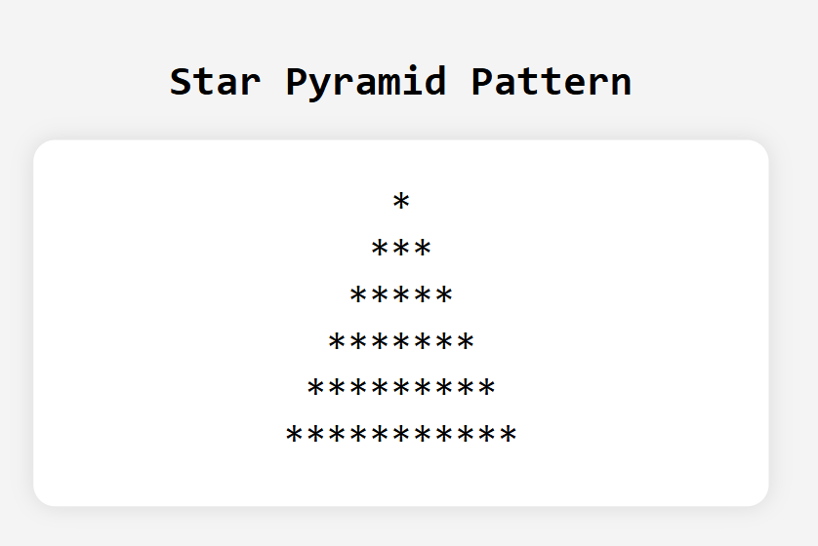
PRN: 2421100256
Name:Ghadge Dhanshri Prakash
Class:MCA-I
Roll No:12
ASSIGNMENT NO :14
Q. Write a HTMl , Javascript code to accept number and check whether it is 1) Palindrome number 2) Armstrong
<!DOCTYPE html>
<html lang="en">
<head>
<meta charset="UTF-8">
<title>Number Check: Palindrome & Armstrong</title>
<style>
body {
font-family: Arial, sans-serif;
padding: 20px;
background-color: #f9f9f9;
}
.container {
max-width: 500px;
margin: auto;
padding: 30px;
background-color: #fff;
border-radius: 10px;
box-shadow: 0 0 10px rgba(0,0,0,0.1);
}
h2 {
text-align: center;
color: #333;
}
input, button {
width: 100%;
padding: 10px;
margin: 10px 0;
font-size: 16px;
}
.result {
margin-top: 20px;
font-weight: bold;
text-align: center;
}
</style>
</head>
<body>
<div class="container">
<h2>Palindrome & Armstrong Checker</h2>
<input type="number" id="numInput" placeholder="Enter a number" />
<button onclick="checkNumber()">Check</button>
<div class="result" id="result"></div>
</div>
<script>
function checkNumber() {
let num = document.getElementById("numInput").value;
let resultText = "";
if (num === "") {
document.getElementById("result").innerText = "Please enter a number.";
return;
}
// Convert to number
let originalNum = parseInt(num);
// Check for Palindrome
let reversed = num.split("").reverse().join("");
let isPalindrome = (num === reversed);
// Check for Armstrong
let sum = 0;
let temp = originalNum;
let digits = num.length;
while (temp > 0) {
let digit = temp % 10;
sum += Math.pow(digit, digits);
temp = Math.floor(temp / 10);
}
let isArmstrong = (sum === originalNum);
// Output results
resultText += `Number: ${originalNum}<br>`;
resultText += `Palindrome: ${isPalindrome ? "Yes ✅" : "No ❌"}<br>`;
resultText += `Armstrong: ${isArmstrong ? "Yes ✅" : "No ❌"}`;
document.getElementById("result").innerHTML = resultText;
}
</script>
</body>
</html>

OUTPUT
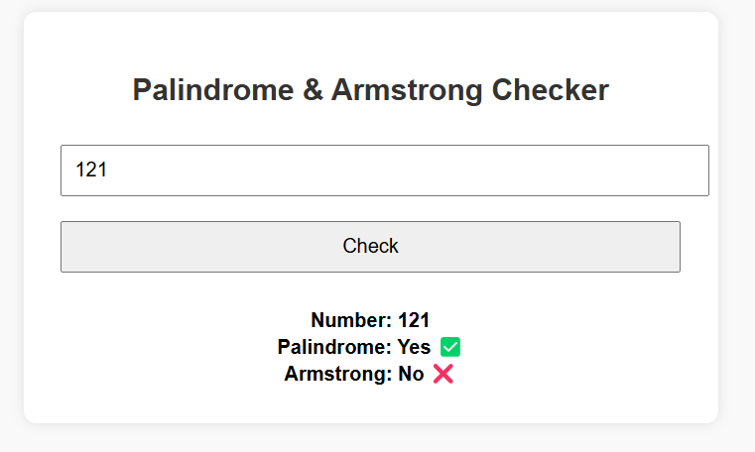

PRN: 2421100256
Name:Ghadge Dhanshri Prakash
Class:MCA-I
Roll No:12
ASSIGNMENT NO :15
Q. Demonstration of PHP control structure.
<!DOCTYPE html>
<html>
<head>
<title>PHP Control Structures Demo</title>
</head>
<body>
<h2>PHP Control Structure Demonstration</h2>
<?php
// Example 1: if-else
$num = 10;
echo "<h3>1. if-else Statement</h3>";
if ($num > 0) {
echo "$num is a positive number.<br>";
} else {
echo "$num is not a positive number.<br>";
}
// Example 2: switch
echo "<h3>2. switch Statement</h3>";
$day = "Wed";
switch ($day) {
case "Mon":
echo "Today is Monday";
break;
case "Tue":
echo "Today is Tuesday";
break;
case "Wed":
echo "Today is Wednesday";
break;
default:
echo "Some other day";
}

// Example 3: for loop
echo "<h3>3. for Loop</h3>";
for ($i = 1; $i <= 5; $i++) {
echo "Iteration: $i <br>";
}
// Example 4: while loop
echo "<h3>4. while Loop</h3>";
$count = 1;
while ($count <= 3) {
echo "Count is: $count <br>";
$count++;
}
// Example 5: foreach loop
echo "<h3>5. foreach Loop</h3>";
$colors = ["Red", "Green", "Blue"];
foreach ($colors as $color) {
echo "Color: $color <br>";
}
?>
</body>
</html>

OUTPUT

